What is C sharp
- C# (C-Sharp) is an object-oriented programming language
- C# is used to develop web apps, desktop apps, mobile apps, games.

What are Comments
- Comments help to write description about code
- Comment is not checked by compiler
- There are two types of comments
  - Single Line
  - Multi Line

What is Single Line comment
- Single-line comments start with two forward slashes (//).
- Any text between // and the end of the line is ignored by C# (will not be executed).

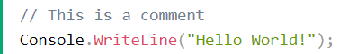

What is Multi Line comments
- Multi-line comments start with /* and ends with */.
- Any text between /* and */ will be ignored by C#.

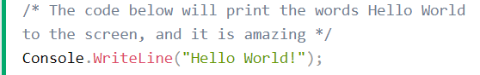

Data Types

What is Data Types
- A data type specifies the type and size variable values.



How many kinds of Data Type
- Two Kinds of Data Types

Hierarchy of Data Type
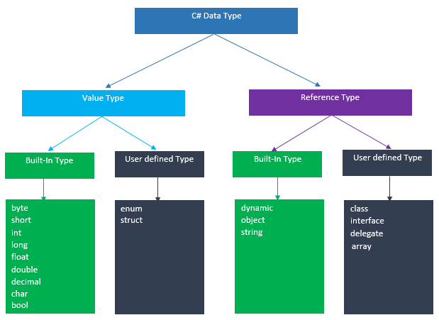
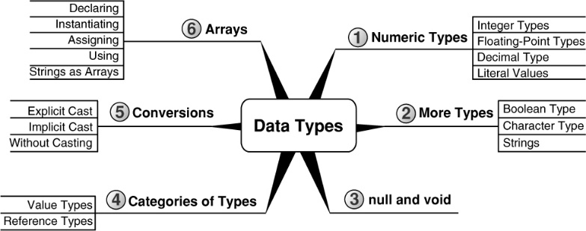

What is Value Type Data Type
- Directly stores the value of a variable in memory
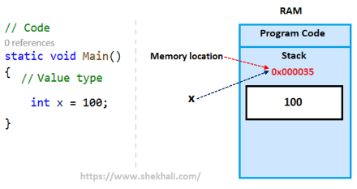
- When Value Type Variable value is assigned to another variable then Value is directly copied and both Variable work independently
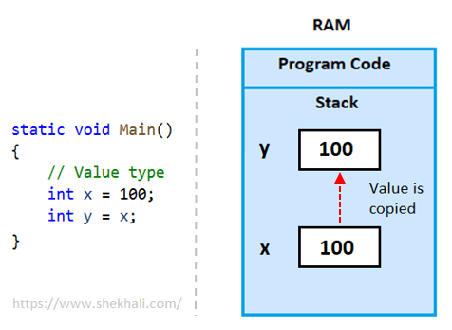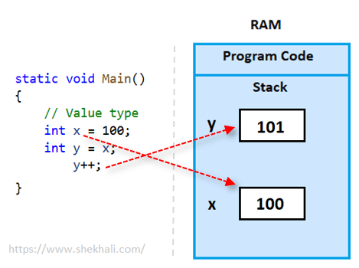

What is Reference Type Data Type
- They store the address of variable i.e. they contain the reference to a variable.
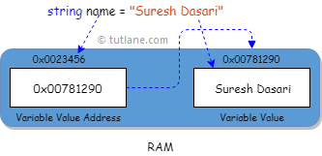
- If the data is changed by one variable, the other variable will automatically get the updated value.
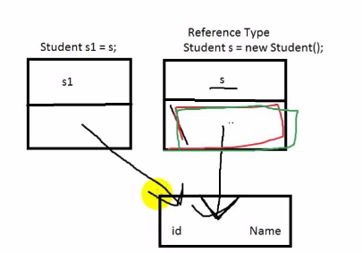

Variable

What is variable?
- Variables are containers for storing data values.
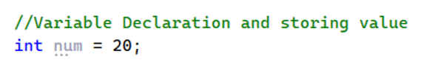
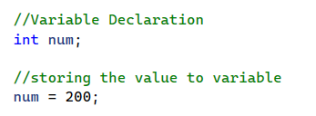

How Many Kinds of Variable
- There are fives kinds of Variable as below
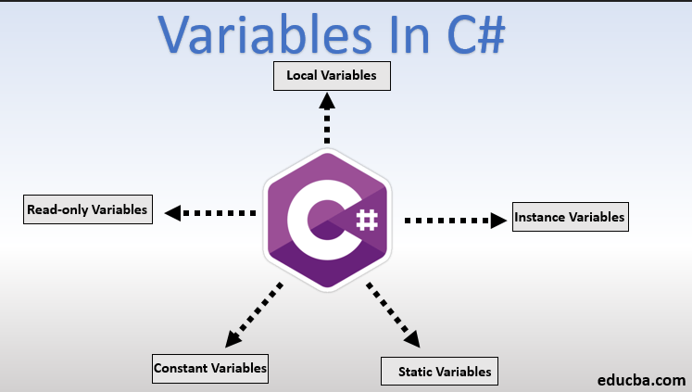

What is Local Variable
- A local variable defined within a method or block or constructor
- variables exist only within the block and we can access these variables only within the block only
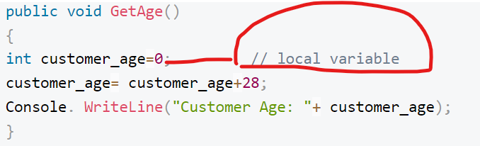

What is Instance Variable or Non – Static Variables
- the instance variables are declared in a class but declared outside of any method, block or constructor
- These variables are created once the object of a class created and it will destroy when the object is destroyed

- Instance Variable belongs to object of class
- Each Object of class maintain separate copy of instance variable value

- Instance variables are called the non-static variables
- With instance variables, we can use the access specifiers.

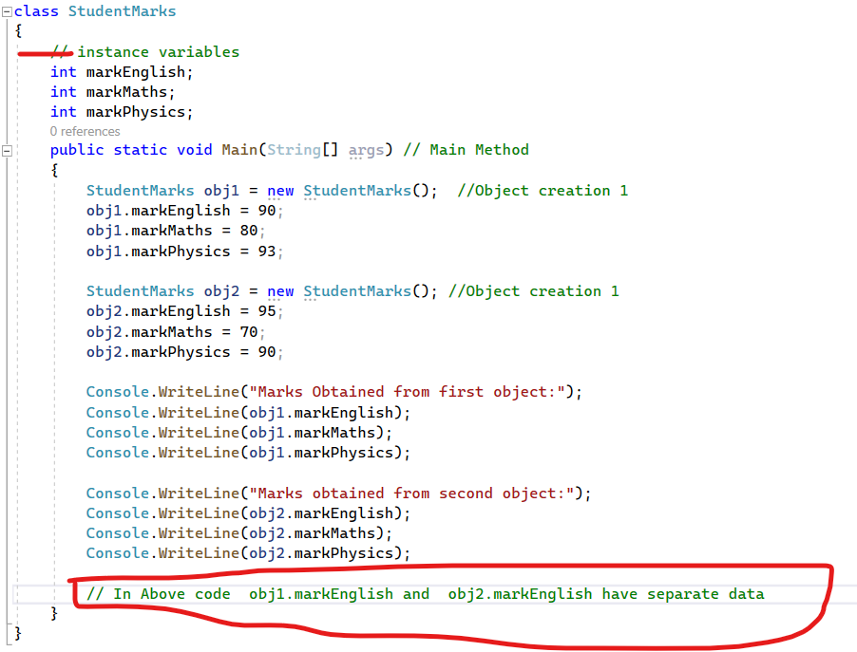

What is Static Variable or class Variable
- A static variable is declared using the keyword static
- We can access static variable with class name only – like className.Variable

- A static variable is created at the beginning of the program execution and destroys at the end of the execution
- Static variables are also called as class variables
- For accessing static variables, we no need to create an object of the class

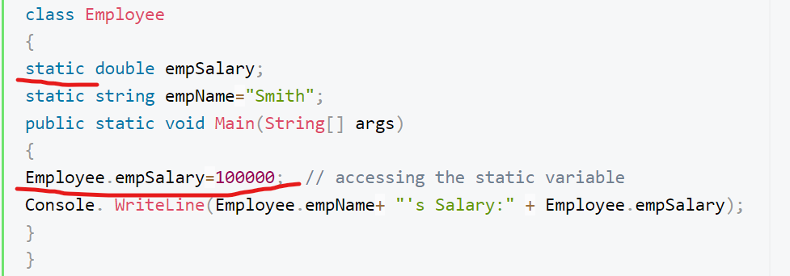

What is constants Variable
- The constant variable is declared by using the ‘const’ keyword,
- The value of constant variable must be initialized/given at the time of the declaration
- constant variable Value cannot be altered or changed later in program once it declared and assigned the value
- constant variable does not need the instance/object of the class for initializing or accessing it
- constant variable can be accessed using class name like – ClassName.ConstantVariable
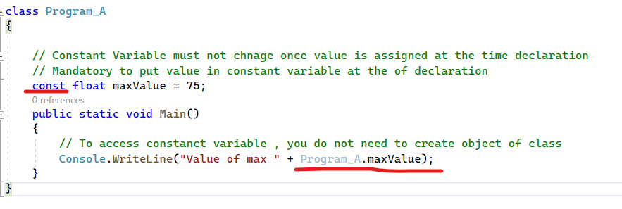

What is Read-Only Variable
- A read-only variable is declared using the keyword ‘read-only‘
- Read Only variable value only can be set as below
  - at the time of declaration
  - or inside constructor of class

- read-only variables cannot be altered/Modified/changed later in the program
- There is no compulsion/mandatory to initialize a read-only variable at the time declaration (but you need in constant variable)
- Read Only variable does need the instance/object of the class for accessing it

Setting read only variable at time declaration

Setting Read Only value inside constructure

Constant Variable Vs Read-Only Variable
Constant Variable | Read-Only Variable
Value must be set in variable at time of variable declaration | Value set in variable is optional at time of declaration  It is not necessary to set variable value at time of variable declaration
To access constant Variable, we do not need to create object of class, it can be assessed using class name | To access read only Variable we must need to create object of class, it cannot be assessed using class name

Casting and Boxing

What is Type Casting
- Typecasting helps us to assign one kinds of data type to another kinds of data type
- It allows us to convert data from one data type to another data type

Here Byte to Int happening
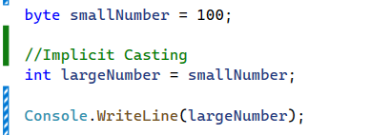

Kinds of Type Casting
- Implicit casting
- Explicit casting
- Non-compatible type casting

What is Implicit type casting
- Implicit casting is done automatically by the compiler
- convert the smaller data type to bigger data type is called implicit type casting
- Data is copied without any data loss
- Implicit Type casting Situation
  - byte->short->int->long->float->double

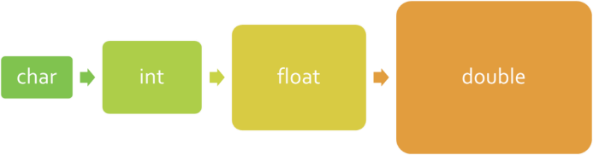

Byte (smaller data type) to Int (Bigger Data type)

What is Explicit type casting
- bigger data type to smaller data type conversion is called “Explicit typecasting”
- There is possibility of data loss
- This is not automatically done by the C# compiler
- Casting is applicable with compatible data types only

- Explicit Type casting situation
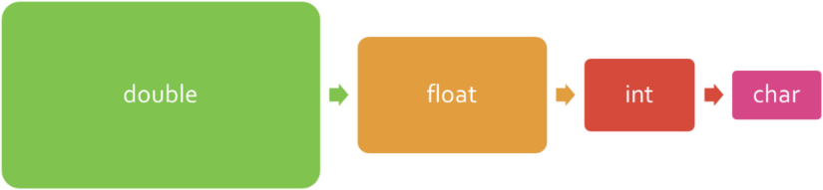
  - Byte>short<int<long<float < double
- Code for explicit casting

- Smaller_dataType variableName=(Smaller_dataType)Bigger_dataType_Value;

non-compatible type casting
- Sometimes we cannot use implicit or explicit conversion because the data types are too different
- For example, the compiler will throw an error when converting string to int data types.
  - We can use Convert.ToInt32() class or the int.Parse() method to convert the data.
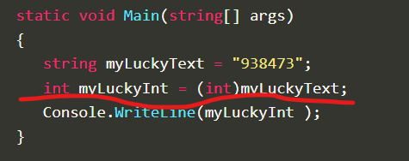

What is Boxing
- Boxing is the implicit conversion of a value type to a reference type.
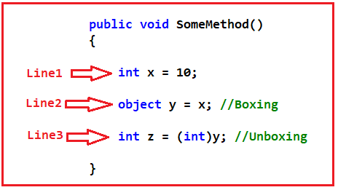

What is Unboxing
- Unboxing is an explicit conversion from the type object to a value type

Operator - not interview

What is Operator
- Operators in C# are special characters (such as "+", ".", "^", etc.) and they perform specific transformations on one, two or three operands
- Operators allow processing of primitive data types and objects.

Kinds of Operator
- Arithmetic operators – they are used to perform simple mathematical operations.
- Assignment operators – allow assigning values to variables.
- Comparison operators – allow comparison of two literals and/or variables.
- Logical operators – operators that work with Boolean data types and Boolean expressions.
- Binary operators – used to perform operations on the binary representation of numerical data.
- Type conversion operators – allow conversion of data from one type to another.

https://introprogramming.info/english-intro-csharp-book/read-online/chapter-3-operators-and-expressions/
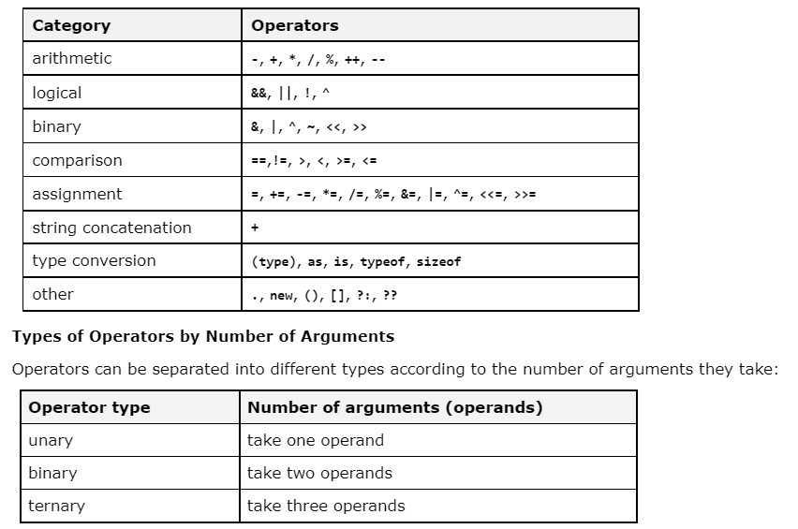

Loop

What is loops in c sharp
- Loop is a control flow statement which allows a block of code to be executed for a specified number of times .
- It can also run until a certain condition is met .

How many kinds of loops are there ?

For loop : used to execute a block of code for a specific number of times.
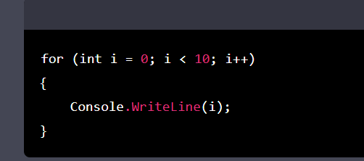

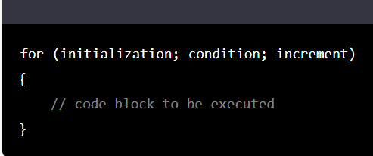

While : this loop is used to execute a block of code as long as certain condition is true.

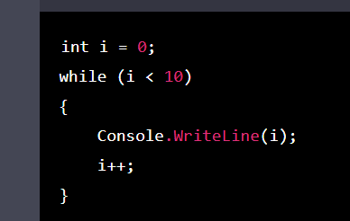

Do_While : This loop is similar to while loop but the block of code is executed at least once .

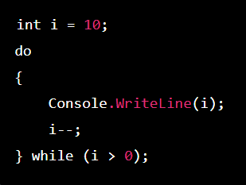

For _Each loop : is used to iterate over the elements of a collection, such as an array or a list.

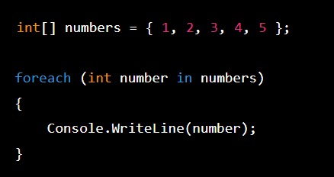

Array

What is Array in c # ?

- It is a collection of items that are stored in a contiguous block of memory.
- In array there are several ways to create and initialize an array :
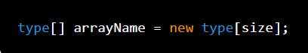

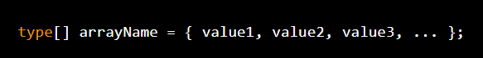

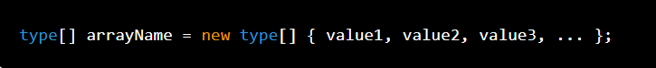

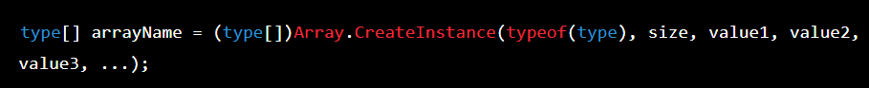

How Many kinds of arrays are there ?
- There are two types of arrays are there .

Single _Dimensional Arrays :
  - A single-dimensional array is a linear structure that stores a fixed number of elements in a single row or column.

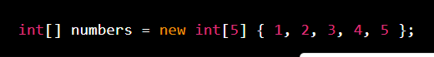

Multi_ Dimensional Array : It can have two or more dimensions .

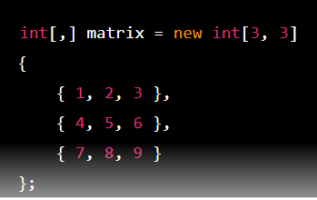

Jagged Array /Arrays of Arrays : Array where the length of each array can be different .

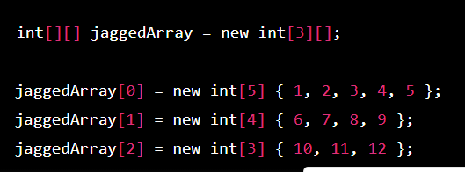

Class

What is class
- Class is blueprint of object
- A class can includes variables and methods
  - Variable represent data
  - Method represents action
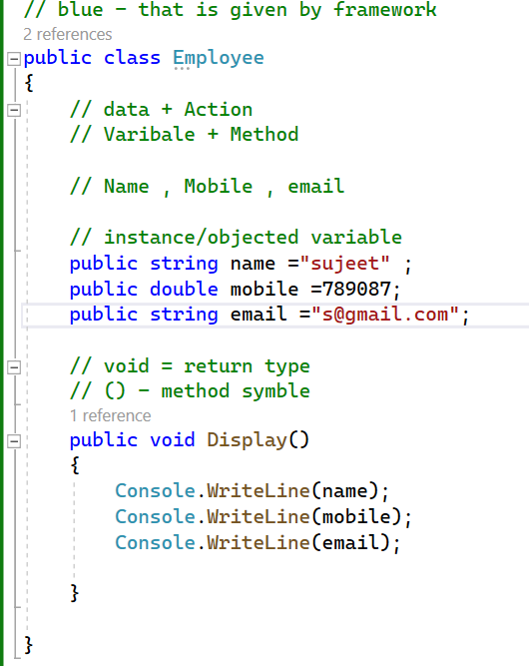

Object

What is object
- Object is an instance of a class .
- We create object of class so that we can call method of a class or anything within the class .

How to create object
- An object is created from a class.
- Object is created using NEW keyword .

- 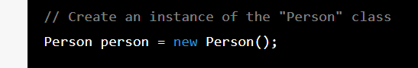

What can be accessed/called using object class
- We can access member variables, methods and anything within the class .

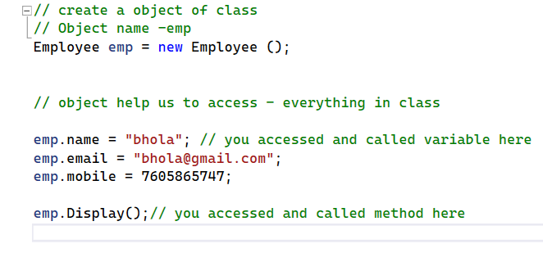

Method

What is method
- A method is a block of code that performs a specific task/operation

- One method can call another method
- Method can be called using object of class
- If method is static then method can be called using class name only
- Methods can take zero or more parameters as input
- Method can return a value (data type, class , array ) or return nothing (Void)

Kinds of Parameterized method

Method with variable parameterized
- Ddddd
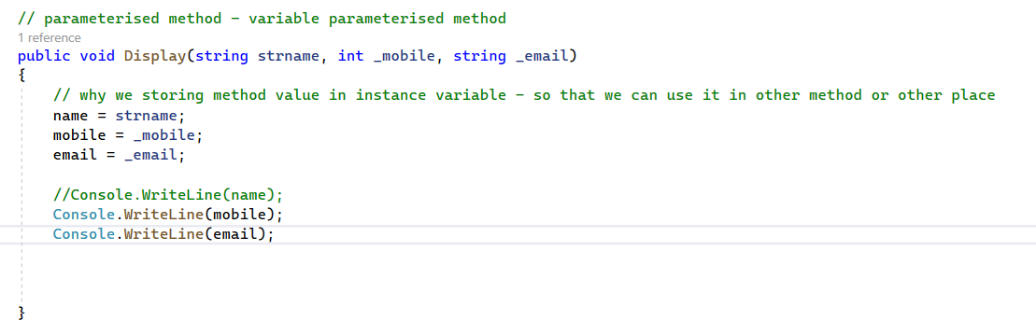
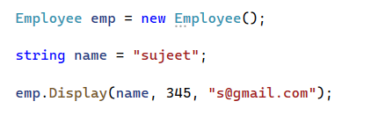

Method with class parameter
- Dd

Method with class parameter and variable parameter

What is method return type

Why we need method to return non-void (Int/double. array, class)
- d

What is static method

What is method overloading

What is method signature

What is pass By value
- fff

What is pass by Reference
- dd
- In pass by reference – Variable must be assigned with value when calling the method

What is pass by out
- Pass by out behave like pass by ref
- In pass by out – Variable assignment is optional when calling the method

Difference between Pass by ref and pass by out

